Artificial Intelligence
BTech ICT/CSE Sem VI, Winter Semester 2018-19

Name of the student : JIVESH PODDAR

Student ID: 16BIT020

Exercise I:
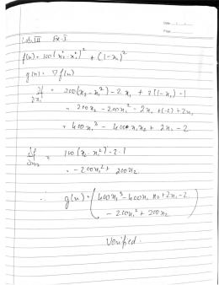
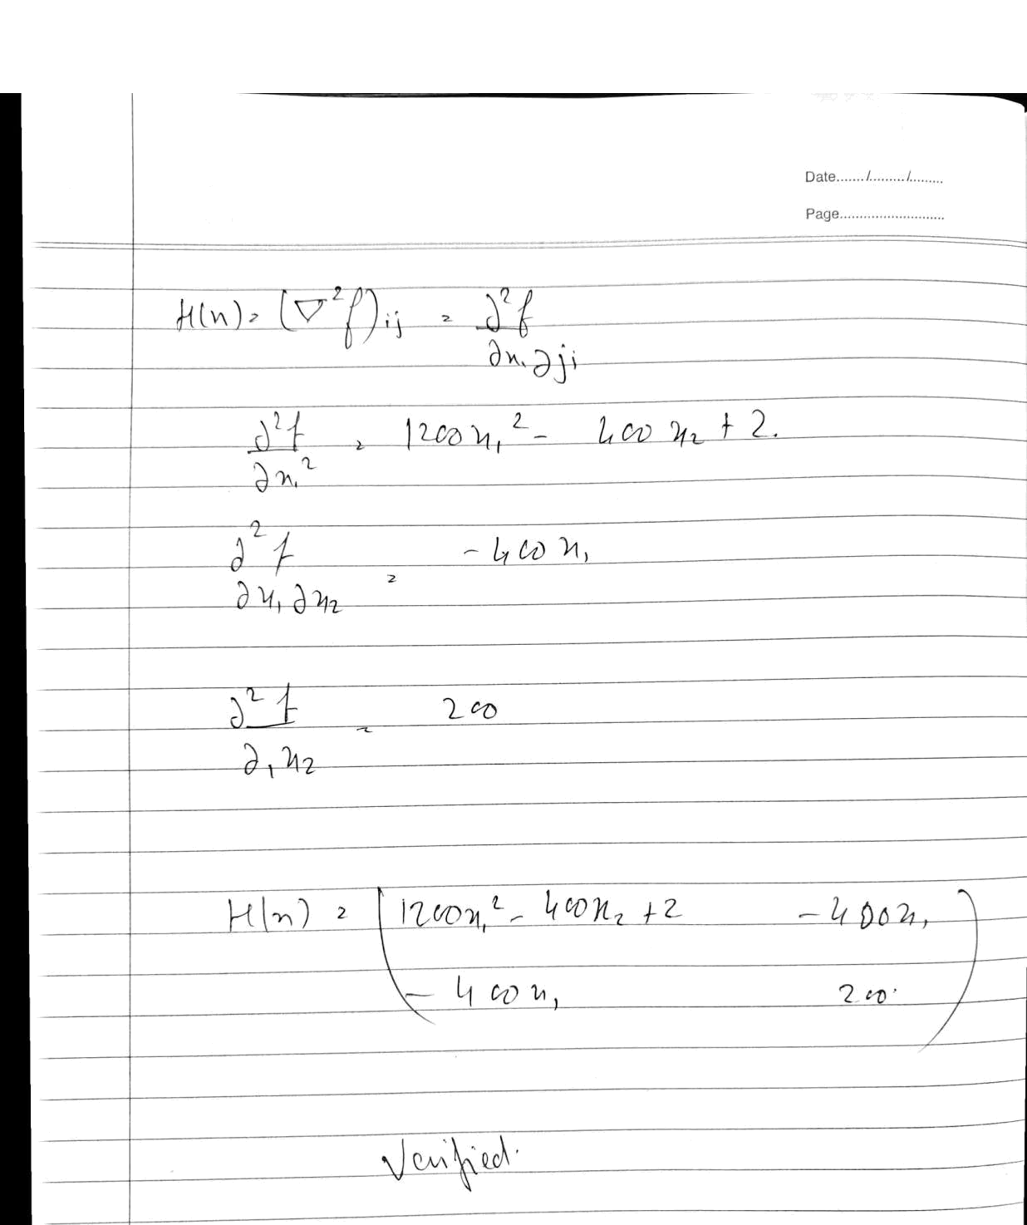

Exercise 2 :

clear
function​​[​f​, ​g​, ​H​]​=​myfunc​(​x​)
​f​​=​​100​*​(​​x​​(​2​)​​-​​x​​(​1​)​^​2​)​^​2​​+​​(​1​​-​​x​​(​1​))​^​2
​g​​(​1​)​​=​​-​​400​*​(​​x​​(​2​)​​-​​x​​(​1​)​^​2​)​*​​x​​(​1​)​​-​​2​*​(​1​​-​​x​​(​1​))
​g​​(​2​)​​=​​200​*​(​​x​​(​2​)​​-​​x​​(​1​)​^​2​)
​H​​(​1​,​1​)​​=​​1200​*​​x​​(​1​)​^​2​​-​​400​*​​x​​(​2​)​​+​​2
​H​​(​1​,​2​)​​=​​-​400​*​​x​​(​1​)
​H​​(​2​,​1​)​​=​​H​​(​1​,​2​)
​H​​(​2​,​2​)​​=​​200
endfunction
function​​f​=​rosenbrock​(​x1​, ​x2​)
​f​​=​​100​*​(​​x2​​-​​x1​^​2​)​^​2​​+​​(​1​​-​​x1​)​^​2
endfunction

myfunc​([​-​1.2​;​1​])
- ​=​​linspace​(​-2​,​1​,​20​) y ​=​​linspace​(​-​2​,​1​,​20​)

- ​=​​feval​(x,y,rosenbrock​ ) surf​(​x,y,z​'​)
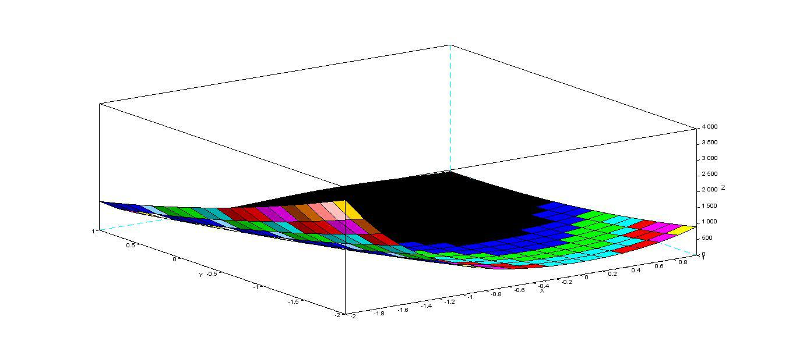

Output: 24.2

The results are the same as those found analytically.

Exercise 3 & 4:

clear
function​​[​f​, ​g​, ​H​]​=​myfunc​(​x​)
​f​​=​​100​*​(​​x​​(​2​)​​-​​x​​(​1​)​^​2​)​^​2​​+​​(​1​​-​​x​​(​1​))​^​2
​g​​(​1​)​​=​​-​​400​*​(​​x​​(​2​)​​-​​x​​(​1​)​^​2​)​*​​x​​(​1​)​​-​​2​*​(​1​​-​​x​​(​1​))
​g​​(​2​)​​=​​200​*​(​​x​​(​2​)​​-​​x​​(​1​)​^​2​)
​H​​(​1​,​1​)​​=​​1200​*​​x​​(​1​)​^​2​​-​​400​*​​x​​(​2​)​​+​​2
​H​​(​1​,​2​)​​=​​-​400​*​​x​​(​1​)
​H​​(​2​,​1​)​​=​​H​​(​1​,​2​)
​H​​(​2​,​2​)​​=​​200
endfunction

function​​f​=​rosenbrockmat​(​x​)

​f​​=​​100​*​(​​x​​(​2​)​​-​​x​​(​1​)​^​2​)​^​2​​+​​(​1​​-​​x​​(​1​))​^​2

endfunction

x0 ​=​[​-​1.2​;​1​]
[​f , g , H ​]​​=​​myfunc​(​x0 ​)
[​z k​]​​=​​numderivative​(​​rosenbrockmat​, x0,​[]​,​[]​,​"blockmat"​)

Difference ​=​H ​-​k;
disp(​Difference​)​

Output :

-0.0000171 4.967D-08

4.967D-08 5.960D-08

The difference between the num derivative function and the analytical value is minimal and therefore we can say that the function is very close to analytical analysis.

